|  |
| --- |
| harkirat singh gill  Sunnysinghgill78@gmail.com |
|  |

# introduction

|  |
| --- |
| This project is related to make a Russian roulette game which should include win/loss and total Score user should be given two chances |
|  |

# design

|  |
| --- |
| I started by creating the background image in photoshop I added the score, win and losses label in photoshop |
| After that I stared adding buttons I added 4 buttons load, spin, fire and try again  I added picture box and loaded the background image |

# form1

I created the form 1 added buttons, labels and text box. user will fill his/her name in the text box that will appear on the next form after clicking play form 1 will be hidden and 2 will be displayed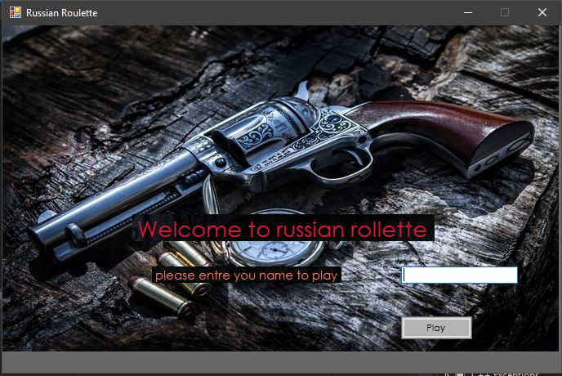

# form2

Form 2 is the main form. This is the area where user will play the game. he/she will start by clicking on load button that will load one bullet in the gun as soon as clicking the button the load button will be disabled 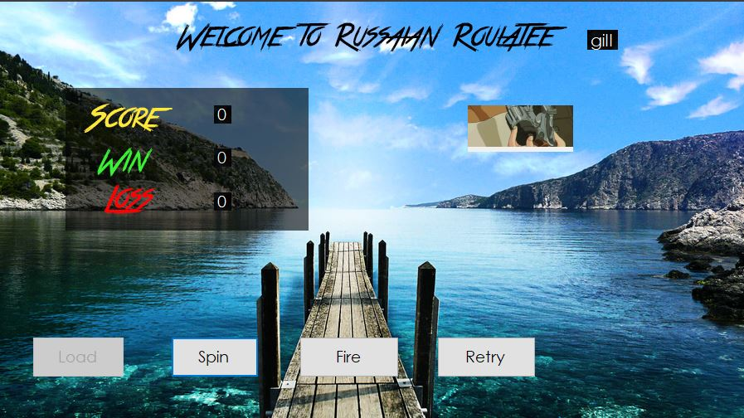

After that the user will click the spin button that will spin the gun after clicking the spin button it will also get disabled and user will hear sound of the gun spinning and a gif will appear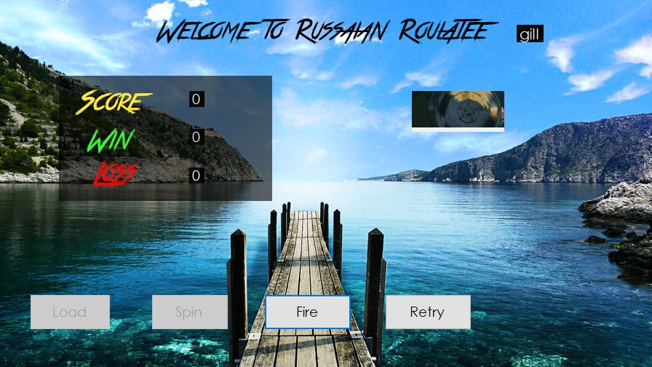

After clicking the spin button user will click fire button. clicking the fire button will display the result and play the sound of firing bullet and a gif will appear. After clicking the spin button user will get two output either he/she will win or lose.

If user lose. he/she will be given a second change. if user losses again he/she will lose the round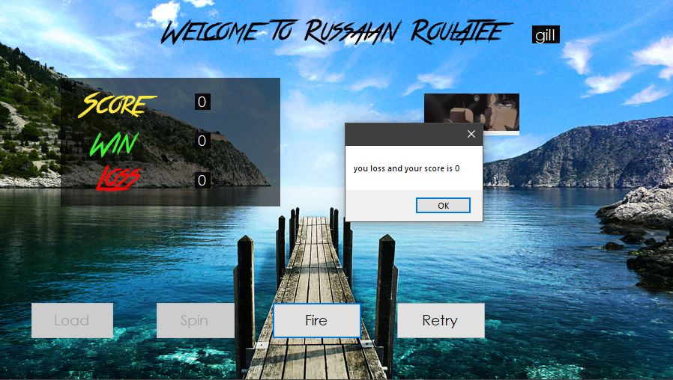

And the score board will be updated. if the user wins the then a 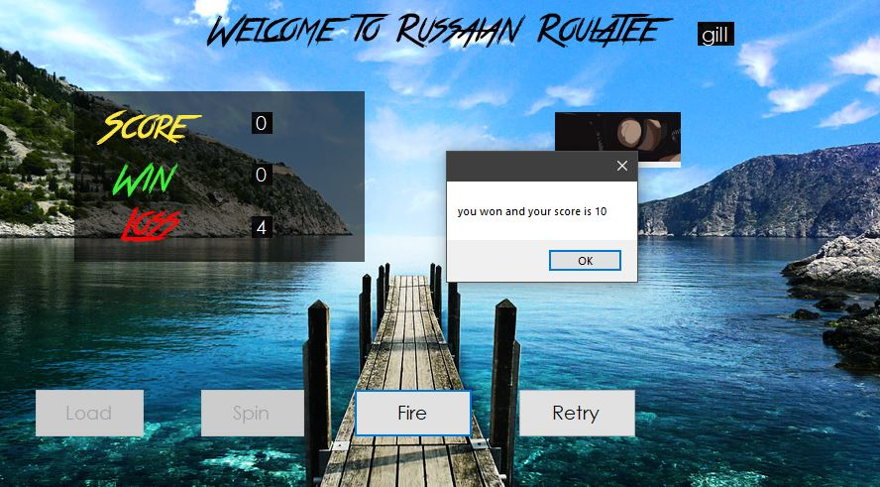pop up box will appear, 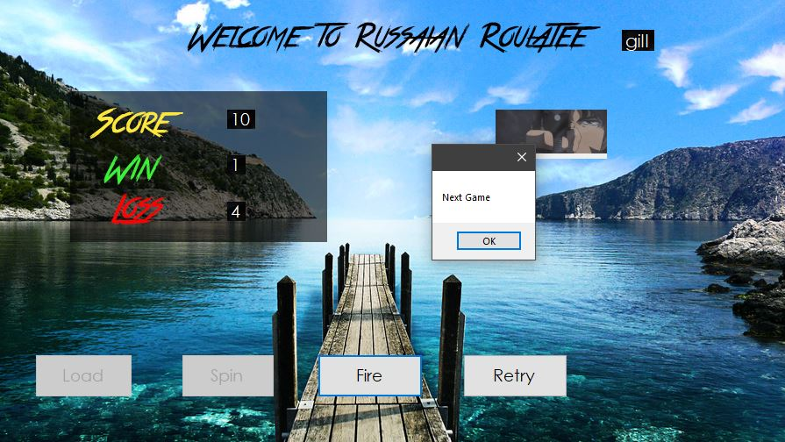and the score will be updated and another pop up will appear with the message “next game” and all the Button will be rest for the second round and second round will start